

**MARMARA UNIVERSITY**

**FACULTY OF ENGINEERING**

CSE3055

Database Systems

Project Step #4

|  |  |  |
| --- | --- | --- |
|  | Student Id | Name Surname |
| 1 | 150119815 | Şevval Alp |
| 2 | 150199723 | Reyyan Rana İnan |
| 3 | 150119733 | Emre Kaan Bilge |
| 4 | 150122828 | Melih Sinan Çubukçuoğlu |

Introduction:

Aim of the Database Systems’ project step 4 is to create a simple user-friendly web interface based on previous steps’ queries. The web page is going to be visualized in Microsoft Visual Studio environment with ASP.NET Web application (.NET Framework) with C# programming language.

Implementation:

The web interface which is designed for Alpin Pasta Parti has options like inserting new customer, deleting customers and viewing customers’ information from its database and does these options from the procedures which are created in the 3rd part of the project with MSsql.

Inserting new customer:

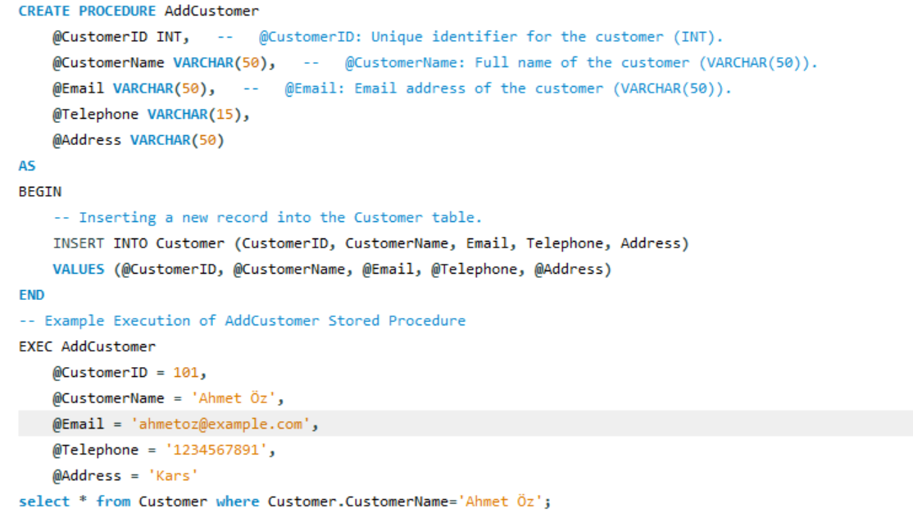

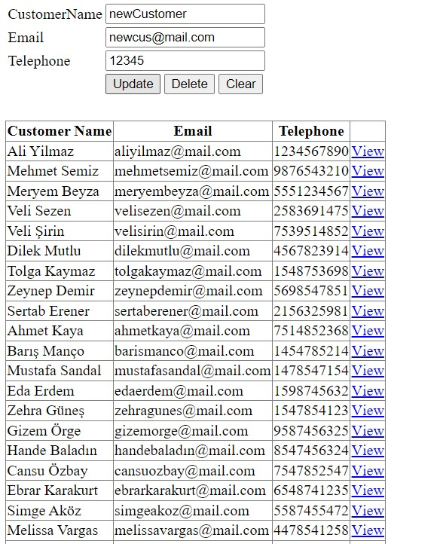

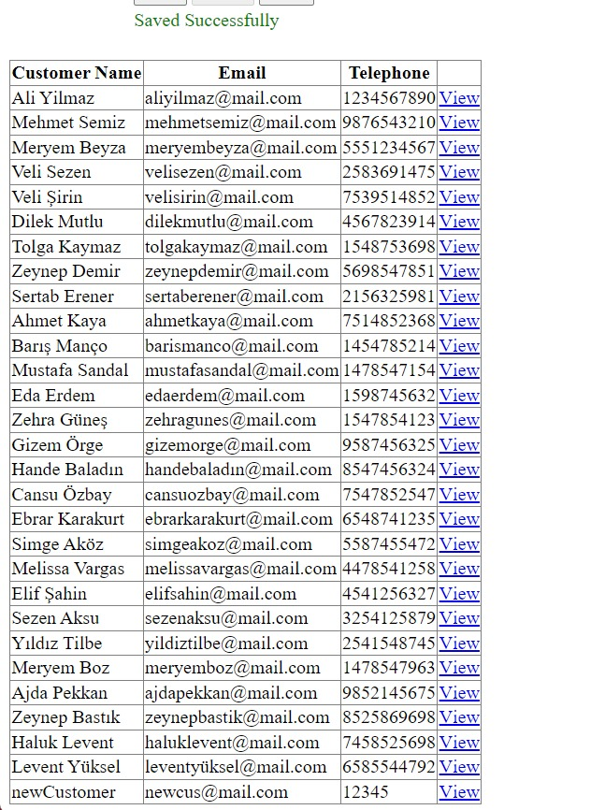

This SQL code defines a stored procedure named AddCustomer. A stored procedure is a precompiled collection of one or more SQL statements that are stored in the database and can be executed as a single unit. In this case, the stored procedure is designed to insert a new customer record into the Customer table.

Deleting a customer:

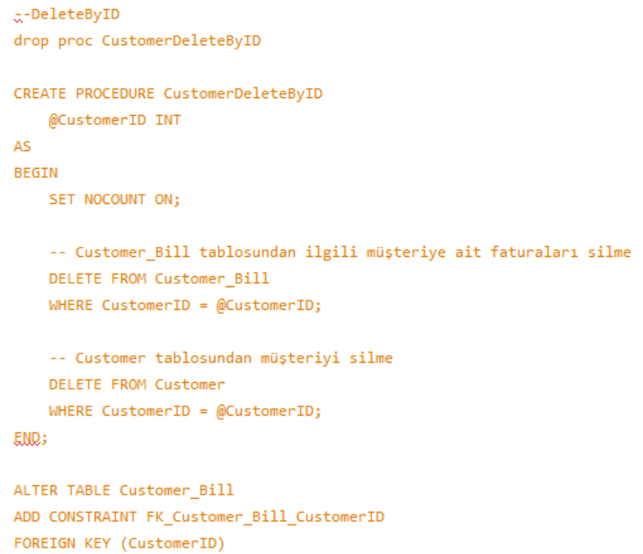



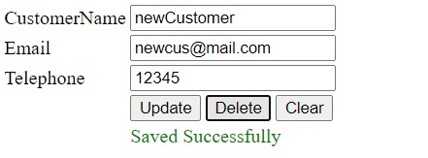

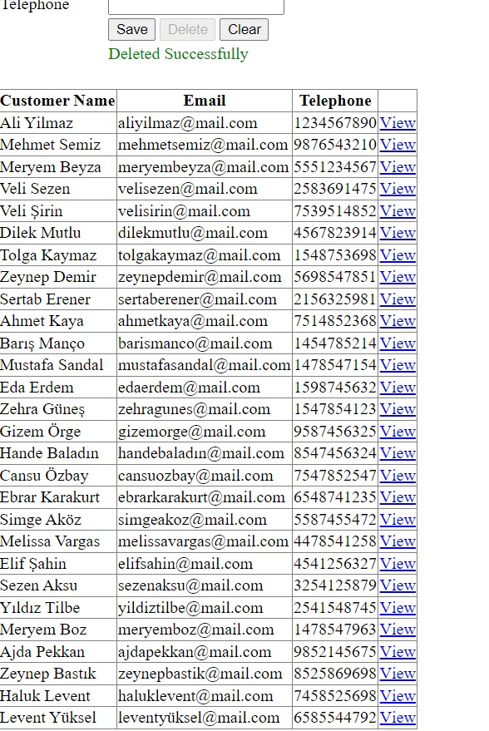

This SQL script performs several tasks related to deleting a customer by their ID (@CustomerID) from the Customer table, including associated records in the Customer_Bill and Customer_Order tables. Additionally, a foreign key constraint is added to the Customer_Bill and Customer_Order tables to ensure referential integrity. SELECT * FROM Customer; Retrieves and displays all records from the Customer table, showing the current state after the deletion operation. This script ensures that when a customer is deleted, related records in the Customer_Bill and Customer_Order tables are also removed, maintaining referential integrity in the database. The foreign key constraint helps enforce this relationship.

Viewing customer information:

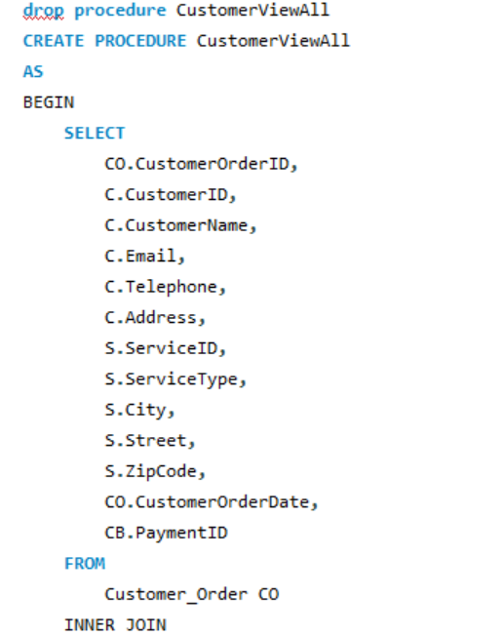

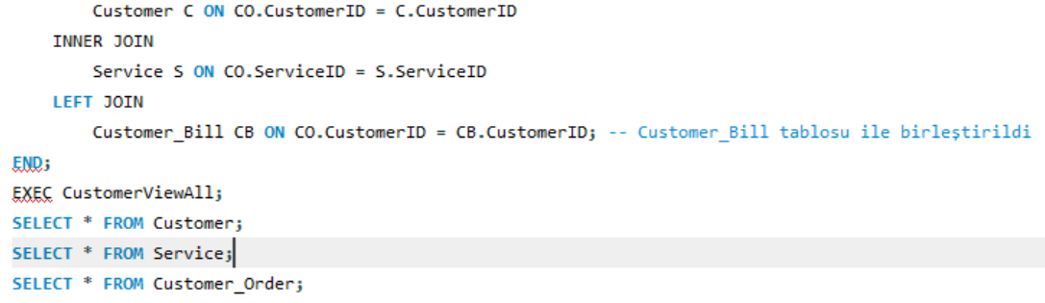

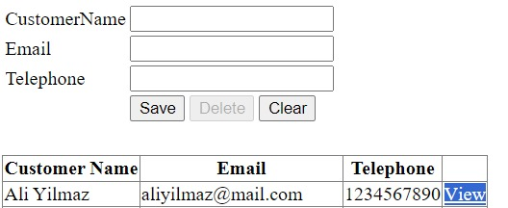

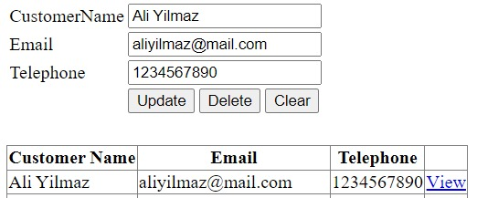

This SQL code defines a stored procedure named CustomerViewAll, drops the procedure if it already exists, and then executes the stored procedure. Following that, it includes three SELECT statements to retrieve and display the contents of the Customer, Service, and Customer_Order tables. EXEC CustomerViewAll;: This executes the CustomerViewAll stored procedure, which retrieves and displays a result set based on the defined logic in the SELECT statement. After running this code, you'll see the result sets for each SELECT statement, showing the combined data from the joined tables in the case of the CustomerViewAll stored procedure, and individual data from the Customer, Service, and Customer_Order tables.

CONCLUSION:

The analysis and exploration of the database for the party organization web site have provided valuable insights into the customer management and order processing aspects of the business. The database includes a well-structured Customer table with essential information such as CustomerID, CustomerName, Email, Telephone, and Address. The CustomerViewAll stored procedure allows for a comprehensive view of customer details, including associated orders and billing information. The Customer_Order table captures order-specific details, including CustomerOrderID, ServiceID, and CustomerOrderDate. The relational structure ensures a clear link between customers and their orders. The Service table provides information about different services, including ServiceType, City, Street, and ZipCode. The use of foreign key relationships, as seen in the INNER JOIN and LEFT JOIN operations within the CustomerViewAll stored procedure, demonstrates a commitment to maintaining database integrity. This ensures that data relationships are accurate and reliable. The stored procedures AddCustomer and CustomerDeleteByID provide functionality for adding new customers and deleting existing customer records. This supports effective data management and user interaction with the database. In conclusion, the database design and stored procedures provide a solid foundation for the development of a party organization web site. The integration of customer management, order processing, and billing information ensures a comprehensive and cohesive user experience, contributing to the success and efficiency of the organization's operations.